Topic 3 – 5 – Analyzing Graph Features – Teaching set 1
1. [C] Why do vertical asymptotes happen?
This problem is about where a vertical asymptote happens, vs. why a vertical asymptote happens.
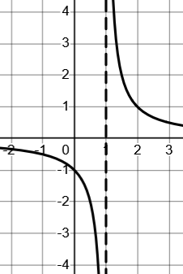
You know $f\left(x\right)=\frac{1}{x - 1}$ has a vertical asymptote at $x=1$. Some students come up with a test: “ah, there’s a vertical asymptote when you divide by 0”. This is a sort-of right-ish test that can tell you where a vertical asymptote can happen. It doesn’t tell you why it happens there. What’s the logical connection between dividing by 0 and the shape you actually see in the graph?
Consider this table of y-values as x approaches 1 from the right-hand side:
x $f(x)$ $y-value$
1.1 $\frac{1}{0.1}$ $10$
1.01 $\frac{1}{0.01}$ $100$
1.001 $\frac{1}{0.001}$ $1000$
a. Try and capture in words what this table tells you about why $\frac{1}{x-1}$ has a vertical asymptote at x = 1. What’s the connection between what you see here and the shape you see in the graph? (Do this verbally).
b. What about when x approaches 1 from the left-hand side? What happens then?

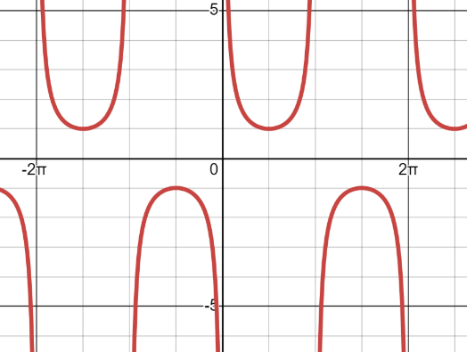
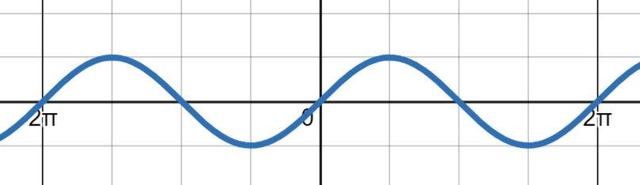
2. [C] Here are two graphs. One is $y=sin⁡(x)$ and one is $y=csc⁡(x)$
a. In $y=sin⁡(x)$, as $x→π$ what does $sin⁡(x)$ approach?
b. Use the idea from problem 1 to explain why $y=csc⁡(x)$ has a vertical asymptote at $2π$. Don’t just say “it’s when you divide by 0” (since that doesn’t tell you why). Try and capture the core idea verbally; then write it down. (in other words, no need to produce any data tables).
c. Why is the “U” shape facing downwards in the interval $π$ to $2π$? Why do the “U” shapes alternate directions?
c. Why aren’t any of the graph’s y-values between -1 or 1? (there’s that empty horizontal band)

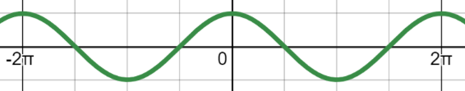
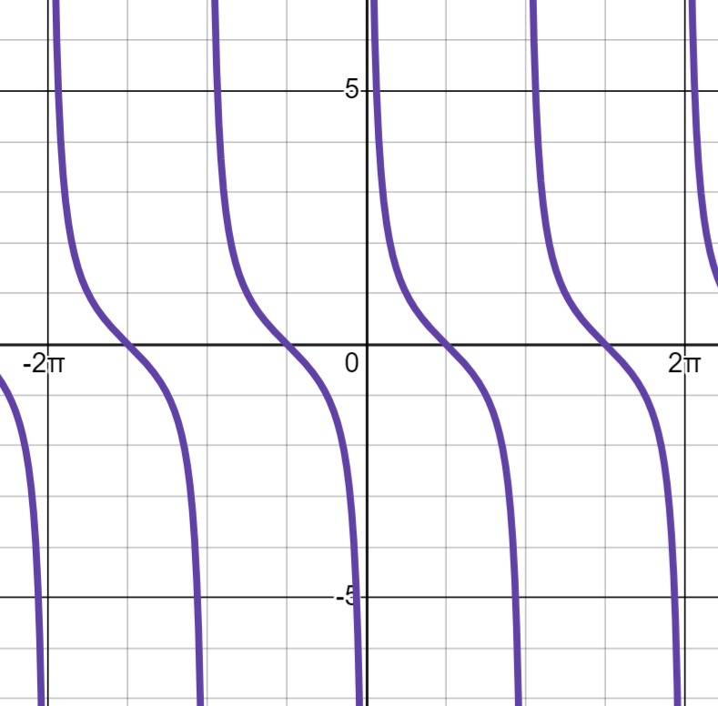

3. [C] Here are graphs of $y=sin⁡(x)$, $y=cos⁡(x)$ and $y=cot⁡(x)$.
a. Where are the asymptotes located? Why are they there?
b. Why are the “S” shapes sloped “downhill” that way? (In other words, as x increases, y values decrease until the next repetition).

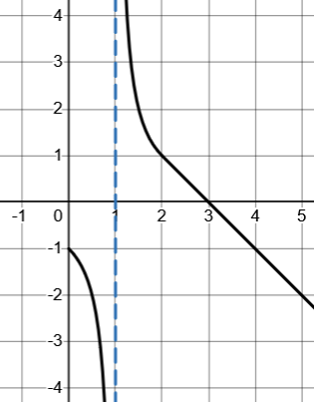
4. [C]
If this is a graph of $y=f(x)$ for some function f.
Sketch as carefully as you can the graph of $y=\frac{1}{f(x)}$. Think about where there will be vertical asymptotes and how to connect other key points you know.

5. [C]
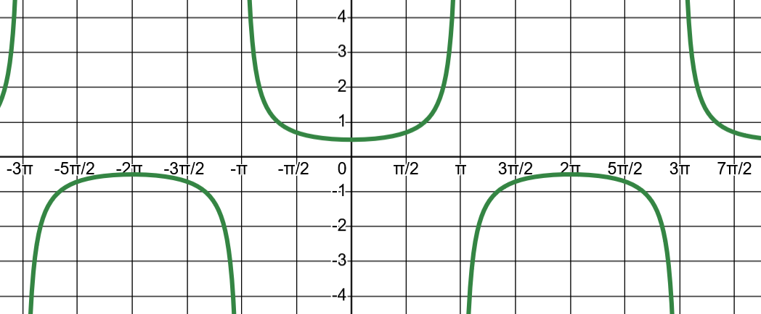
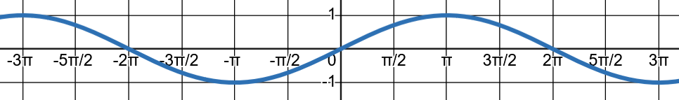
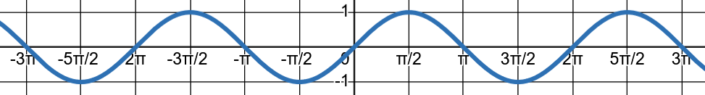
a). The top graph there looks kind of like $y=sec⁡(x)$. Give a few reasons someone who doesn’t know what the secant graph looks like could check for themselves that would convince them it isn’t $y=sec⁡(x)$.
b). This is actually the graph of Consider $y=\frac{\sin\left(\frac{x}{2}\right)}{\sin\left(x\right)}$ . Your partner who is still stuck in the mindset: “When you divide by 0, that gives you a vertical asmptote”. Here when x = 0 you divide by 0, but there’s no vertical asmptote.
Why isn’t there a vertical asymptote at x = 0? Contrast that with an explaination for why there is still an asymptote at $x=π$.
c). You may have noticed that as $x→0$ the y-values approach $\frac{1}{2}$ and wonder why that is. If you did; good mathematical intuition! Feel free to tinker in desmos, but try and come up with some intuition for why that should make sense. See if you can express it in words.
(a very careful explaination will have to wait until later, but the intuition for why is available now for the seeing if you look).

Topic 3 – 5 – Analyzing Graph Features – Teaching set 1 – Solutions
1. [C] Why do vertical asymptotes happen?
This problem is about where a vertical asymptote happens, vs. why a vertical asymptote happens.

You know $f\left(x\right)=\frac{1}{x - 1}$ has a vertical asymptote at $x=1$. Some students come up with a test: “ah, there’s a vertical asymptote when you divide by 0”. This is a sort-of right-ish test that can tell you where a vertical asymptote can happen. It doesn’t tell you why it happens there. What’s the logical connection between dividing by 0 and the shape you actually see in the graph?
Consider this table of y-values as x approaches 1 from the right-hand side:
x $f(x)$ $y-value$
1.1 $\frac{1}{0.1}$ $10$
1.01 $\frac{1}{0.01}$ $100$
1.001 $\frac{1}{0.001}$ $1000$
a. Try and capture in words what this table tells you about why $\frac{1}{x-1}$ has a vertical asymptote at x = 1. What’s the connection between what you see here and the shape you see in the graph?
As x-values get closer to 1 (from “the right side of the graph” (values larger than 1)), y values increase toward infinity. I see that same shape happening in the graph in the part circled.
b. What about when x approaches 1 from the left-hand side? What happens then?
From the graph I can see that as x-values get closer to 1 from the other side, the y-values are going to negative infinity. You can think about this numerically also. Let’s pick an x-value very close to 1 but which is smaller than 1, like 0.999. Plugging-in to find the y-value, we get $f\left(0.999\right)=\frac{1}{0.999 - 1}=\frac{1}{-0.001}=-1000$.


2. [C] Here are two graphs. One is $y=sin⁡(x)$ and one is $y=csc⁡(x)$
a. In $y=sin⁡(x)$, as $x→π$ what does $sin⁡(x)$ approach?
You can see that as x-values get closer to $π$, y-values get closer to 0.
b. Use the idea from problem 1 to explain why $y=csc⁡(x)$ has a vertical asymptote at $2π$. Don’t just say “it’s when you divide by 0” (since that doesn’t tell you why). Try and capture the core idea verbally; then write it down. (in other words, no need to produce any data tables).
The idea last time was if you have $\frac{1}{\left(something approaching 0\right)}$ the fraction will get larger and larger toward infinity. That’s the shape of a vertical asymptote. In this case, $y=\frac{1}{sin⁡(x)}$ and we know that as $x→π$, $\sin\left(x\right)→0$. That means that as $x→π$, $\csc\left(x\right)→∞$, which means there’s a vertical asymptote at $x=π$.
c. Why is the “U” shape facing downwards in the interval $π$ to $2π$? Why do the “U” shapes alternate directions?
If the U shape were upward, the y-value would be going to positive infinity as they approach the vertical asymptotes that create the U shape. But between $π$ and $2π$, $sin⁡(x)$ is negative. Therefore, $\frac{1}{sin⁡(x)}$ has to be negative also. That means the y-values have to go to negative infinity, creating the downward facing U.
c. Why aren’t any of the graph’s y-values between -1 or 1? (there’s that empty horizontal band)
A general strategy for understanding things like this is to ask: “what would need to happen if it were true?” Let’s choose a specific y-value like $\frac{1}{2}$. If the graph had a y-value of $\frac{1}{2}$ we know, literally that for some x-value $\frac{1}{sin⁡(x)}=\frac{1}{2}$. If we multiply by the denominator on both sides we get $\sin\left(x\right)=2$. But we know this is impossible since the sine function can’t output a value larger than 1.
This same reason applies for any number between -1 and 1. Any y-value between -1 or 1 would require that $sin⁡(x)$ output a number larger than 1 or smaller than -1, which is impossible. That’s why there are no y-values in that band.




3. [C] Here are graphs of $y=sin⁡(x)$, $y=cos⁡(x)$ and $y=cot⁡(x)$.
a. Where are the asymptotes located? Why are they there?
There are vertical asymptotes at every integer multiple of $π$. $\cot\left(x\right)$ is the same as $\frac{\cos\left(x\right)}{\sin\left(x\right)}$. Notice that sin(x) is in the denominator.
The reason vertical asymptotes occur at multiples of pi is because as x approaches (gets closer to) multiples of $π$, the value of $sin⁡(x)$ in the denominator is getting closer to 0 at the same time that the value of $cos⁡(x)$ in the numerator is getting closer to 1. If you imagine a fraction that’s $\frac{(number getting closer to 1)}{(number getting closer to 0)}$ the overal value of that fraction will be going to infinity or negative infinity.
b. Why are the “S” shapes sloped “downhill” that way? (In other words, as x increases, y values decrease until the next repetition).



There are a few related thoughts you could have here. Imagine x-values gradually increasing from slightly more than 0 to $\frac{π}{2}$. The numerator, $\cos\left(x\right)$, is changing from (slightly less than) 1 down to 0. Meanwhile, the denominator, $sin⁡(x)$, is changing from slightly larger than 0 up to 1. So, as x increases the numerator is getting smaller at the same time that the denominator is getting bigger. That will produce smaller y-values approaching 0, which is one way to think about that “downward” slope.
+
+
+
+
-
-
A different thought is this: two simple facts force this shape when you think about them happening together.
The first fact is that as x approaches integer multiples of $π$, y-values go to either infinity or negative infinity. I think about it like there being “walls” at those x-values and as you get closer to the wall you’ve got to go up it, or down it.
The second fact is the pattern of when sine and cosine output a positive or negative value. Look at the picture here. In the first vertical strip (when x is between $0$ and $\frac{π}{2}$ ) both sine and cosine are positive. So when you divide them, you know all the y-values for $cot⁡(x)$ must be positive. That means as we approach “the wall” at 0, the curve must go up.
In the second vertical strip (when x is between $\frac{π}{2}$ and $π$ ), sine is positive but cosine is negative. That means cot(x) must be negative. So as the curve approaches the wall at $x=π$, it must go down (since if it went up, you’d get y-values that weren’t negative).

4. [C]
Let’s think about this part in a minute…
If this is a graph of $y=f(x)$ for some function f.
Sketch as carefully as you can the graph of $y=\frac{1}{f(x)}$.
Let’s think about key things we know.
- At x = 3 there will be a vertical asymptote, since $\frac{1}{f(x)}$ will have a denominator getting smaller toward 0.
- When x > 3, $\frac{1}{f(x)}$ will be negative.
- When $1<x<3$, $\frac{1}{f(x)}$ will be positive.
Let’s graph just that much.
What about the interval from $0≤x≤2?$ We know that when $x=1$, $f\left(1\right)=0$, so $\frac{1}{f(1)}$ will be undefined. But think about what happens as the x-values get closer to 1 from the right-hand side (in other words, $x=1.1, 1.01, 1.001, 1.0001,…$ etc ). The $f\left(x\right)$ values are going to infinity. So $\frac{1}{f(x)}$ must be getting closer and closer to 0.

Not only that but since $f(x)$ is positive, we know $\frac{1}{f(x)}$ must be positive also.
The same analysis applies to the interval from $0<x<1$. The f(x) values approach $-∞$ as $x→1$, which means $\frac{1}{f(x)}$ must be approaching 0 also (since the magnitude of the denominator is getting larger and larger).
The graph will look something like the one on the right there.

5. [C]



a). The top graph there looks kind of like $y=sec⁡(x)$.
Give a few reasons someone who doesn’t know what the secant graph looks like could check for themselves that would convince them it isn’t $y=sec⁡(x)$.
Remember that $\sec\left(x\right)=\frac{1}{cos⁡(x)}$
At x = 0, $\sec\left(0\right)=\frac{1}{cos⁡(0)}=1$. But in this graph we see that at x = 0, the y-value is actually $\frac{1}{2}$.
In the graph, we see a vertical asymptote at $x=π$. In the secant graph, $\sec\left(π\right)=\frac{1}{\cos\left(π\right)}=-1$ which is not an undefined value. So $y=sec⁡(x)$ doesn’t have a vertical asysmptote there.
You could also check other points to show that they don’t match up.
b). This is actually the graph of Consider $y=\frac{\sin\left(\frac{x}{2}\right)}{\sin\left(x\right)}$ . Your partner who is still stuck in the mindset: “When you divide by 0, that gives you a vertical asmptote”. Here when x = 0 you divide by 0, but there’s no vertical asmptote.
Why isn’t there a vertical asymptote at x = 0? Contrast that with an explaination for why there is still an asymptote at $x=π$.
Let’s look at the numerator and denominator separately as $x→0$ for $\frac{\sin\left(\frac{x}{2}\right)}{sin⁡(x)}$.
$$x$$ | 0.1 | 0.05 | 0.01 | 0.005
$$\sin\left(\frac{x}{2}\right)$$ | 0.04997… | 0.024997… | 0.004999… | 0.002499…
$$sin⁡(x)$$ | 0.09983… | 0.049979… | 0.009999… | 0.004999…
$$\frac{\sin\left(\frac{x}{2}\right)}{sin⁡(x)}$$ | 0.50062… | 0.50015… | 0.50000… | 0.50000…

Numerically, you can see that as $x→0$, the denominator is approaching 0, but the numerator is also. The reason that’s important is if the numerator is constant, then $\frac{constant}{value going to 0}$ means the whole fraction gets larger toward infinity. But as you can see in the table, if they’re both going to 0, and the numerator is approximately half as large as the denominator, the ratio will be approximately $\frac{1}{2}$; the y-values won’t go to infinity.
c). You may have noticed that as $x→0$ the y-values approach $\frac{1}{2}$ and wonder why that is. If you did; good mathematical intuition! Feel free to tinker in desmos, but try and come up with some intuition for why that should make sense. See if you can express it in words.

